Net 1061 Switching, Routing, and Wireless Essentials

Name:

Lab: #

Follow the instructions down below for the lab itself. For this lab, all answers need to be in blue font. For the questions right below, answer in complete sentences. If this is a self-grading packet tracer. Ensure you paste the screen shot of your score page at the bottom of the document. You will upload both this document and the pkt file regardless if it is self-grading or not. Let the instructor know if you have any questions.

Lab Analysis Report

1. Using complete sentences summarize work you completed during the lab.
In this lab, I configured the basic settings for R2. Then, I configured all the interfaces used. Then, I verified connectivity and connected to the router using SSH to get information. Finally, I displayed the running configuration on the router.

2. Using complete sentences describe what you learned from the lab. Hint; look at the lab objectives listed at the top of the lab section.
In this lab I learned how to configure a router and its interfaces and connect to it remotely using ssh.

Problems Encountered

1. Using complete sentences describe any problem(s) experienced during lab.
When I went to add a description to the router interfaces, it wouldn’t give me the points for it.

2. Using complete sentences describe how you solved your problem(s).
I didn’t solve my problem.

3. Using complete sentences explain if you needed any assistance with the lab; then list what you learned from that assistance.

Packet Tracer - Basic Router Configuration Review

Addressing Table
Device | Interface | IP Address / Prefix | Default Gateway
R2 | G0/0/0 | 10.0.4.1 /24 | N/A
R2 | G0/0/0 | 2001:db8:acad:4::1 /64 | N/A
R2 | G0/0/0 | fe80::2:a | N/A
R2 | G0/0/1 | 10.0.5.1 /24 | N/A
R2 | G0/0/1 | 2001:db8:acad:5::1 /64 | N/A
R2 | G0/0/1 | fe80::2:b | N/A
R2 | S0/1/0 | 10.0.3.2 /24 | N/A
R2 | S0/1/0 | 2001:db8:acad:3::2 /64 | N/A
R2 | S0/1/0 | fe80::1:c | N/A
R2 | S0/1/1 | 209.165.200.225 /30 | N/A
R2 | S0/1/1 | 2001:db8:feed:224::1/64 | N/A
R2 | S0/1/1 | fe80::1:d | N/A
PC1 | NIC | 10.0.1.10 /24 | 10.0.1.1
PC1 | NIC | 2001:db8:acad:1::10 /64 | fe80::1:a
PC2 | NIC | 10.0.2.10 /24 | 10.0.2.1
PC2 | NIC | 2001:db8:acad:2::10 /64 | fe80::1:b
PC3 | NIC | 10.0.4.10 /24 | 10.0.4.1
PC-3 | NIC | 2001:db8:acad:4::10 /64 | fe80::2:a
PC4 | NIC | 10.0.5.10 /24 | 10.0.5.1
PC-4 | NIC | 2001:db8:acad:5::10 /64 | fe80::2:b

Objectives
Part 1: Configure Devices and Verify Connectivity
- Assign static IPv4 and IPv6 addresses to the PC interfaces.
- Configure basic router settings.
- Configure the router for SSH.
- Verify network connectivity.
Part 2: Display Router Information
- Retrieve hardware and software information from the router.
- Interpret the startup configuration.
- Interpret the routing table.
- Verify the status of the interfaces.

Background / Scenario
This activity requires you to configure the R2 router using the settings from the Addressing Table and the specifications listed. The R1 router and the devices connected to it have been configured. This is a comprehensive review of previously covered IOS router commands. In Part 1, you will complete basic configurations and interface settings on the router. In Part 2, you will use SSH to connect to the router remotely and utilize the IOS commands to retrieve information from the device to answer questions about the router. For review purposes, this lab provides the commands necessary for specific router configurations.

Instructions

Configure Devices and Verify Connectivity

Configure the PC interfaces.
      - Configure the IPv4 and IPv6 addresses on PC3 as listed in the Addressing Table.
      - Configure the IPv4 and IPv6 addresses on PC4 as listed in the Addressing Table.

Configure the router.
Open configuration window
      - On the R2 router, open a terminal. Move to privileged EXEC mode.
      - Enter configuration mode.
      - Assign a device name of R2 to the router.
      - Configure c1sco1234 as the encrypted privileged EXEC mode password.
      - Set the domain name of the router to ccna-lab.com.
      - Disable DNS lookup to prevent the router from attempting to translate incorrectly entered commands as though they were host names.
      - Encrypt the plaintext passwords.
      - Configure the username SSHadmin with an encrypted password of 55Hadm!n.
      - Generate a set of crypto keys with a 1024 bit modulus.
      - Assign cisco as the console password, configure sessions to disconnect after six minutes of inactivity, and enable login. To prevent console messages from interrupting commands, use the logging synchronous command.
      - Assign cisco as the vty password, configure the vty lines to accept SSH connections only, configure sessions to disconnect after six minutes of inactivity, and enable login using the local database.
      - Create a banner that warns anyone accessing the device that unauthorized access is prohibited.
      - Enable IPv6 Routing.
      - Configure all four interfaces on the router with the IPv4 and IPv6 addressing information from the addressing table above. Configure all four interfaces with descriptions. Activate all four interfaces.
      - Save the running configuration to the startup configuration file.
Close configuration window

Verify network connectivity.
      - Using the command line at PC3, ping the IPv4 and IPv6 addresses for PC4.

Question:
Were the pings successful?
Yes.Type your answers here.
      - From the CLI on R2 ping the S0/1/1 address of R1 for both IPv4 and IPv6. The addresses assigned to the S0/1/1 interface on R1 are:
IPv4 address = 10.0.3.1
IPv6 address = 2001:db8:acad:3::1

Question:
Were the pings successful?
Yes.Type your answers here.
From the command line of PC3 ping the ISP address 209.165.200.226.

Question:
Were the pings successful?
Yes.Type your answers here.
From PC3 attempt to ping an address on the ISP for testing, 64.100.1.1.

Question:
Were the pings successful?
Yes.Type your answers here.
      - From the command line of PC3 open an SSH session to the R2 G0/0/0 IPv4 address and log in as SSHadmin with the password 55Hadm!n.
C:\> ssh -l SSHadmin 10.0.4.1

Password:

Question:
Was remote access successful?
Yes.Type your answers here.

Display Router Information
In Part 2, you will use show commands from an SSH session to retrieve information from the router.

Establish an SSH session to R2.
From the command line of PC3 open an SSH session to the R2 G0/0/0 IPv6 address and log in as SSHadmin with the password 55Hadm!n.

Retrieve important hardware and software information.
Open configuration window
      - Use the show version command to answer questions about the router.

Questions:
What is the name of the IOS image that the router is running?
Bootflash:/isr4300-universalk9.03.16.05.s.155-3.S5-ext.SPA.binType your answers here.
How much non-volatile random-access memory (NVRAM) does the router have?
32768k bytes.Type your answers here.
How much Flash memory does the router have?
3223551k bytes.Type your answers here.
      - The show commands often provide multiple screens of outputs. Filtering the output allows a user to display certain sections of the output. To enable the filtering command, enter a pipe (|) character after a show command, followed by a filtering parameter and a filtering expression. You can match the output to the filtering statement by using the include keyword to display all lines from the output that contain the filtering expression. Filter the show version command, using show version | include register to answer the following question.

Question:
What is the boot process for the router on the next reload?
0x2102Type your answers here.

Display the running configuration.
      - Use the show running-config command on the router to answer the following questions filtering for lines containing the word “password”.

Question:
How are passwords presented in the output?
They are encrypted.Type your answers here.
      - Use the show running-config | begin vty command.

Question:
What is the result of using this command?
It shows the configurations of the vty lines.your answers here.
Note: A more specific command would be show running-config | section vty; however, the current version of Packet Tracer does not support the section filtering command.

Display the routing table on the router.
Use the show ip route command on the router to answer the following questions.

Question:
What code is used in the routing table to indicate a directly connected network?
C.Type your answers here.
How many route entries are coded with a C code in the routing table?
3.Type your answers here.

Display a summary list of the interfaces on the router.
      - Use the show ip interface brief command on the router to answer the following question.

Questions:
What command changed the status of the Gigabit Ethernet ports from administratively down to up?
No shutdown.Type your answers here.
What filtering command would you use to display only the interfaces with addresses assigned?
Show ip interface brief | include manual.Type your answers here.
    - Use the show ipv6 int brief command to verify IPv6 settings on R2.

Question:
What is the meaning of the [up/up] part of the output?
Both the link-local and ipv6 are up.
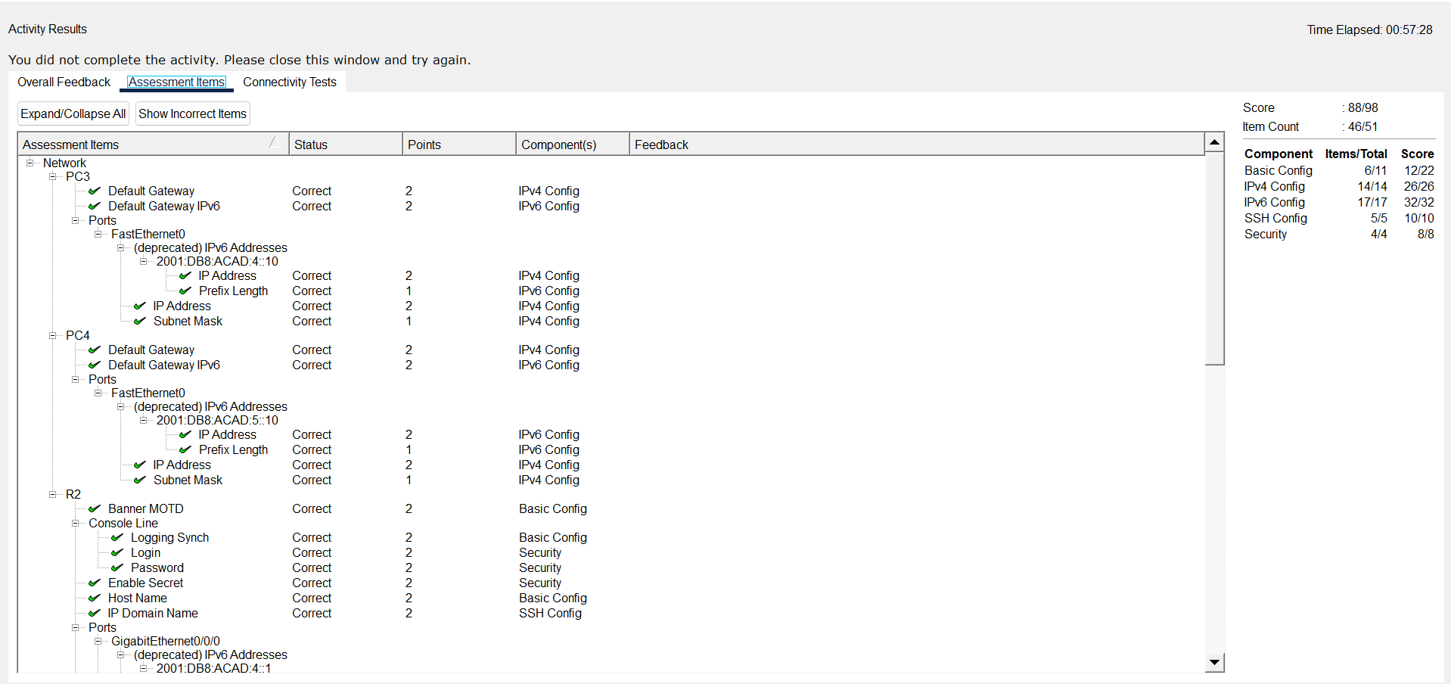your answers here.
Close configuration window
End of document

